**SMARTPHONE PURCHASE ASSISTANCE SYSTEM**

**(PROPOSAL)**

by

EDIRISOORIYA GAMAGE ERANDA

# Introduction

## Context

Smartphone market is a notable example of the bigger the brand is, the better the sales are concept. Bigger brands, with their aggressive marketing techniques, always got great figures on the sales throughout the years (Kadim, 2019). The emerging companies who are focused on good and low-cost smartphones are mostly overshadowed by those aggressive marketing techniques. This problem leads the people to be far from being smart at making purchase decisions and rather wasting money under the “brand-name” hypnosis.

Sri Lankan smartphone market is a good follower of the above methodology. The biggest smartphone manufacturers are popularized among the Sri Lankans by the marketers and make people aware and buy only these brands (refer figure 1.1:1).

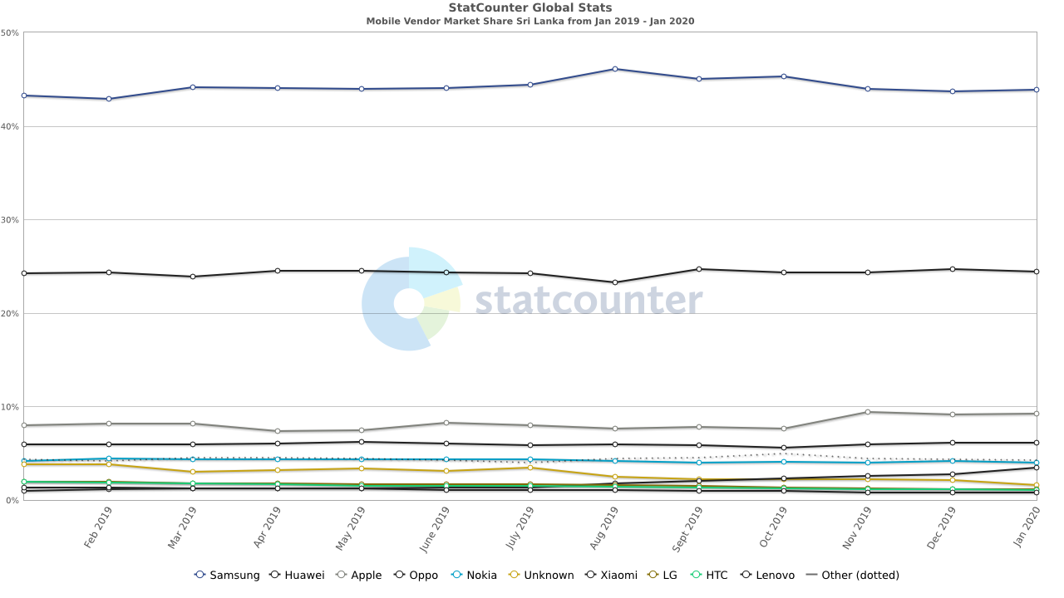

Figure 1.1:1 Mobile Vendor Market Share in Sri Lanka from February 2019 - January 2020 (StatCounter, 2020)

## Problem Statement

The marketing misguidances, the brand-name hypnosis and vastly, the lack of knowledge about updated technology among Sri Lankans, has made the lack of awareness of the availability of the best “bang-for-the-buck” smartphones. Accordingly, the following issues need to be addressed.

* People (General Smartphone Consumers) need a method to identify the best value for their budget.
* People need a method to guide them to good smartphone dealers in the country.
* People need a method to identify the important aspects when buying a smartphone.
* People need a solution which is free of complicated technical jargons/functionalities, for a hassle-free, self-learnt usage.

# The Requirements Specification

## Functional

* To allow the consumer to search for a mobile phone; using *smartphone price* **or** *smartphone brand* **or** *smartphone name*.
* To allow the consumer to identify the main aspects to look for when buying a smartphone.
* To allow consumers to view details of a specific mobile phone.
* To allow the consumer to view the smartphones categorized according to brand names and latest smartphones.

# The Use-Case Diagram

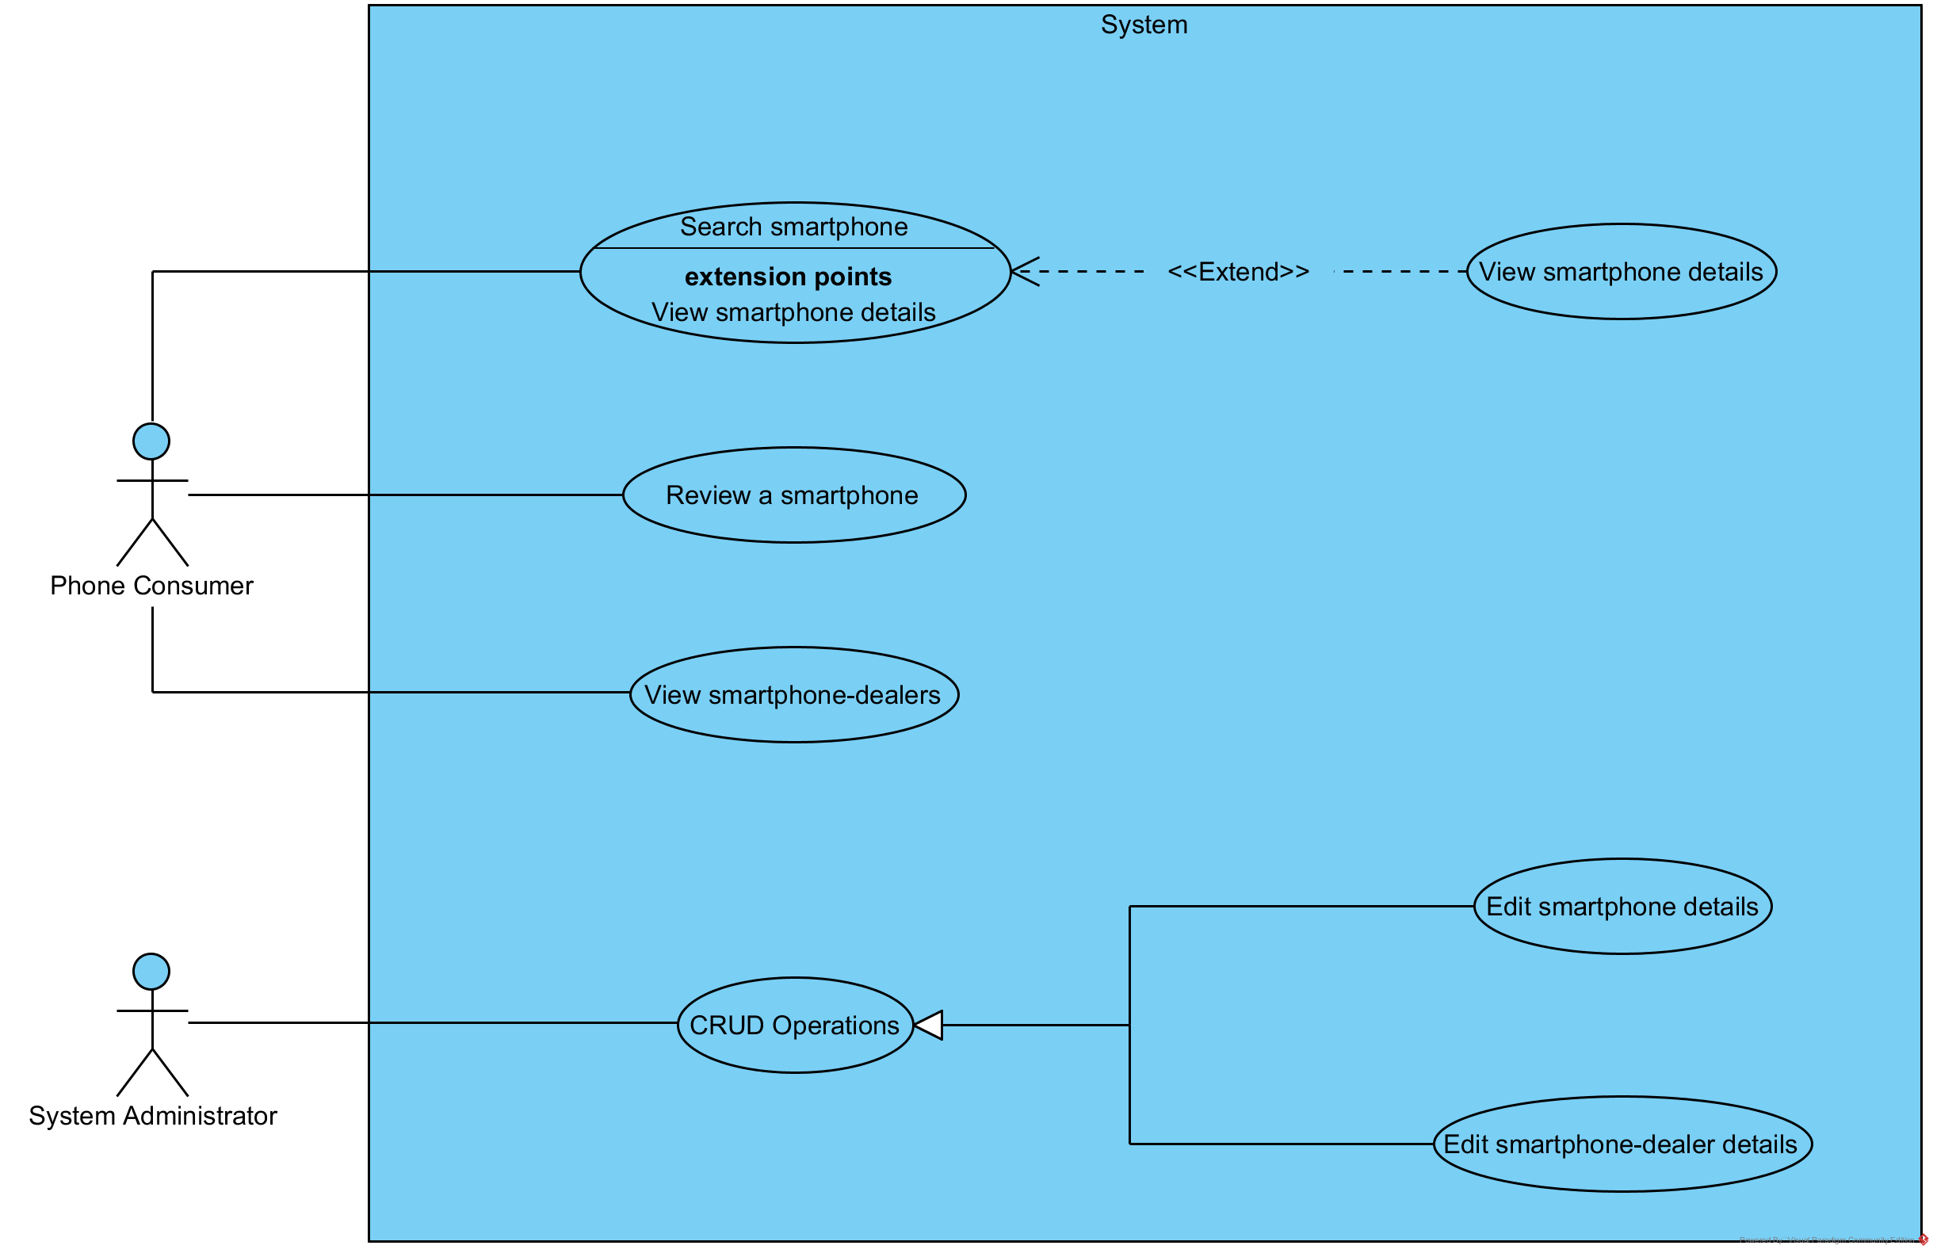

Figure 2.1:1 The Use-Case Diagram

# Functional Decomposition

* **Smartphone Service**

To manage the phones and their details. This service includes the following entities.

* Smartphone
* Smartphone Specification
* User Review
* **User Service**

To manage user accounts. This service includes the following entity.

* User

There are two types of users; ***system administrators*** and ***smartphone consumers***. The sole purpose of a smartphone consumer having an account, is to review a smartphone.

* **Dealer Service**

To manage the phone dealers. This service includes the following entities.

* Dealer
* Dealer Price List

# References

Kadim, G., 2019. *Marketing Power of the Technology Battle: Apple vs Samsung vs Huawei.* [Online]   
Available at: https://pstrategic.com/battle-of-tech-on-marketing/  
[Accessed 1 March 2020].

StatCounter, 2020. *Mobile Vendor Market Share Sri Lanka (Jan 2019 - Jan 2020).* [Online]   
Available at: https://gs.statcounter.com/vendor-market-share/mobile/sri-lanka  
[Accessed 1 March 2020].